# **ECOR 1010 – Introduction to Engineering**

**reverse engineering project**

**Universal Ratchet**

***To:***

Mark Kotwicz Email: markkotwicz@cmail.carleton.ca

***From:***

|  |  |  |
| --- | --- | --- |
| Jacob Martin | 101000849 | jacobamartin@cmail.carleton.ca |
| Keyan Cassis | 101011524 | keyancassis@cmail.carleton.ca |
|  |  |  |

**Lab Section: L17**

**Project Group Number: L17-06**

**Date: 27/11/2015**

**CARLETON UNIVERSITY**

# Table of content

Abstract 3

Introduction 4

Method 4

Results 4

Manufacturing Material

Manufacturing Process

Discussion 5

Failure Mode

Benefits of Redesign

Conclusion 5

Appendix 6,7

IntelliCad Drawing

3D Rendered Model

# abstract

A ratchet is a mechanical tool used to loosen and tighten bolts and screws. It uses different size sockets for different bolt sizes. The problem with a standard ratchet is that it requires a large amount of sockets to ensure that you have the right size for the job. The user must carry around a large box of sockets which takes up both weight and space.

The universal ratchet was designed in 3d modeling software to make the user's life easier giving them a quick and efficient way to loosen and tighten bolts. The universal ratchet uses a single socket with many retractable octagonal pillars. When the pillars are pushed against bolts and screws the pillars that cover the surface area of the bolts retract thus creating a tight and snug fit around it. This allows the user to tighten and loosen bolts as needed by applying a torque on the ratchet. The user can switch between tightening and loosening by switching the lock on the back of the ratchet. The product eliminates the need for multiple sockets for a ratchet and instead has multiple sizes built into a single socket using octagonal pillars. With the redesign we increase efficiency, reduce clutter and give an easy to use tool to the customer.

The product is made entirely out of stainless steel which makes it strong and durable. The product would be mass produced with ease to meet demands and shipped to local hardware stores for customers to purchase.

# Introduction

A ratchet is a mechanical tool used for tightening bolts and screws of various sizes. It is carried in a toolbox along with all of it’s changeable socket sizes. As bolts and screws have a very large variety of sizes and shapes, ratchet tool boxes are often big and heavy because they include dozens of sockets of different sizes. What’s more, losing a single socket, as there are many in toolbox, would result in the user being unable to tighten certain bolt sizes until the socket of the specific size is replaced. For this reason we decided that the ratchet tool could be improved to increase its portability as well as its efficiency.

# Method

The idea of a universal ratchet was formed from the need to have an easy way of tightening and loosening bolts of various sizes. We started with a standard ratchet then from within the socket we added octogonal pillars that would contract to the size of head need for the job. The bolt pushes in these pillars leaving a snug fit around the bolt or screw from the pillars that are located outside the range of the bolt. The user can then use the part in the standard fashion of a ratchet, twisting it until the bolt is tight or loosening it.

# Results

We used creo to design a universal ratchet using the standard ratchet as a template then creating our own built-in socket which would adjust to all bolt and screw sizes. the part is built durable enough that the user will not encounter any problems while loosening or tightening. By using twenty four pillars within the socket we were able to add four different bolt sizes to the product.

**Manufacturing Material:**

The material that we would use for the main body of the universal ratchet would be stainless steel, this is because steel is very durable and will hold its shape even if dropped. Also it will not rust very easily ensuring the product will last longer for the customer. Stainless steel is also very ductile so we can easily shape the sockets and handle.

The octagonal pillars will also be made of stainless steel, this is due to the fact that it is easily shapeable so we can get our desired pillar sizes. Also it provides enough friction between the bolt that when tightening or loosening the bolt will not slip out of place.

**Manufacturing Process:**

The universal ratchet is constructed as one one part unlike a regular ratchet. The mass produced complete part will be created all in the same factory. The raw materials will be melted and shaped into the ratchet’s outer shell and then cooled off till it is completely solid. The mechanical socket with the retractable steel bolts will then be screwed solid into the outer shell. The part will then be distributed to local hardware stores for purchase.

# Discussion

**Failure Mode:**

One way in which our product might fail is, the socket does not meet every customer's specific needs. The universal ratchet only has four different bolt sizes and if a customer needs a size that is not within the range of our products then the tool will not work. one way to fix this problem is to add more rings of pillars increasing the range of sizes that the tool can work with.

**Benefits of Redesign:**

The redesigning of the basic ratchet tool has greatly improved it in many ways. For one, the universal ratchet is much more portable. Rather than carrying a whole toolbox with dozens and dozens of sockets, the user can now simply carry the universal ratchet in a small casing. Not only does this reduce the space taken up by the box, it also reduced the carry weight by a lot because the sockets are made of metal and many of the them in a box is a heavy weight. The universal ratchet is a very innovative and useful product. The part can be used for anything from fixing a bike to construction work on houses and buildings. A mechanic who is repairing a car from beneath it would not have to slide back and change the socket every time. He could simply keep the universal tool on his belt and use it for all bolts and screw sizes. Not only is this much easier for the mechanic, but it also saves him a lot of time of going back and forth. Also, the redesigned tool is fairly esthetic and ergonomic. It is made of shiny stainless steel and has no health risks for the user.

# Conclusion

Overall we were able to greatly improve the standard ratchet, giving the customer an easier and more portable product to use. By making a simple change to a standard socket our product can now do the same work as a regular socket while being more portable and efficient. If we had to change one thing with our product we would add more pillars within the socket to even more increase its size span thus, increasing the the amount of bolts and screws it could tighten and loosen.

# 

# APPENDIX I

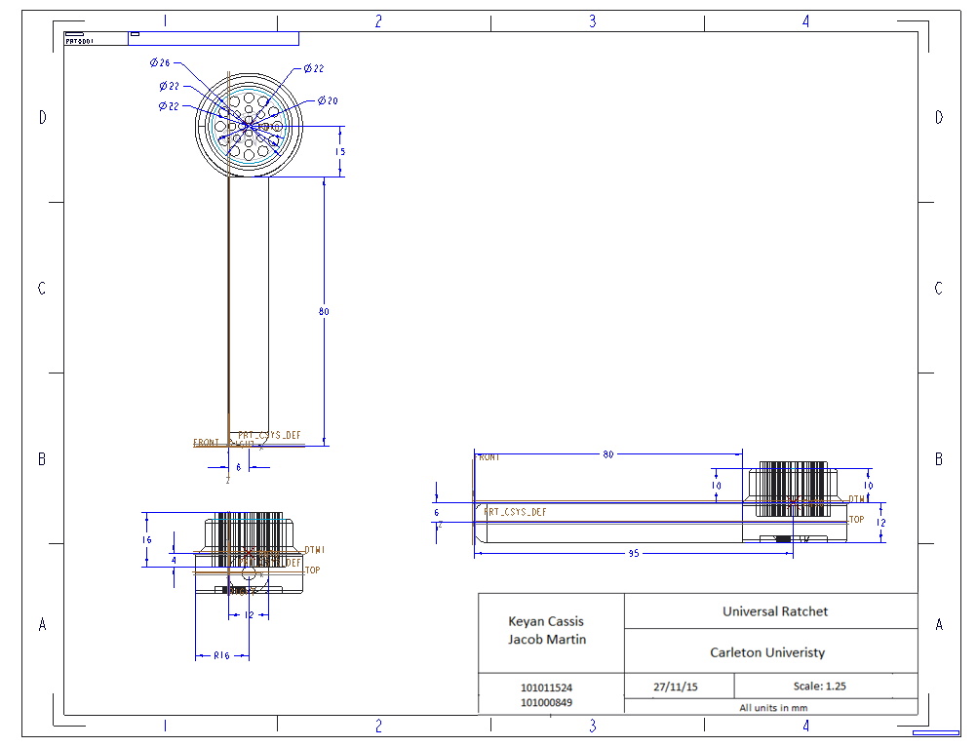

Figure 1: Intellicad orthographic drawing of the universal ratchet.

# APPENDIX II

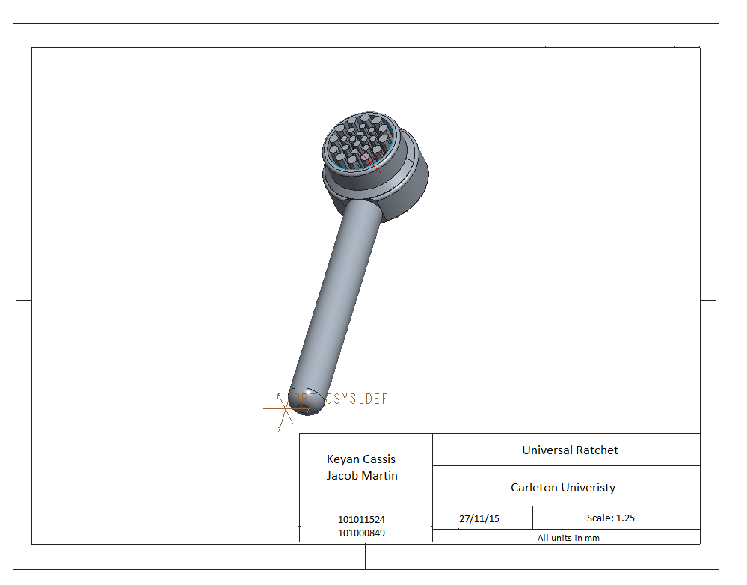

Figure 2: 3D rendered solid model of the universal ratchet.